ADKC Information and Advice Drop-in!
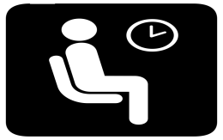
2-4pm on Mondays
(Phone or email)

What services are available during the COVID pandemic?

Any support coping with social isolation?

How do I apply for a Disabled Person’s Parking Badge?

What’s happening to my PIP claim during the pandemic?

What services is ADKC providing during the pandemic?

Contact Marian for information or advice on any of these questions, or any others I haven’t thought of!

Phone 0754 550 6114
OR
Email information@adkc.org.uk

How it will work???

- Phone or email between 2pm and 4pm – leave a voicemail with your number
- if I don’t answer I’m helping someone
- Pour yourself a cup of tea or coffee, glass of juice, or whatever your favourite beverage is
- Get comfortable and wait by the phone/with your emails open - I will aim to get back to you in 10-20 minutes, or straight away if possible!

See you there!
Information Advice Referrals Signposting

