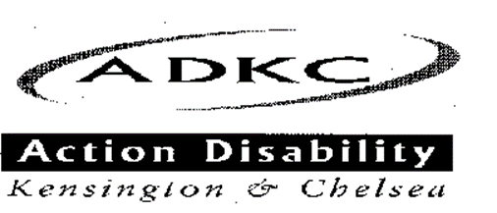

ADKC Centre,
Whitstable House,
Silchester Road,
London, W10 6SB
Voice/ Minicom 020 8960 8888
Fax 020 8960 8282
Email adkc@adkc.org.uk
Website www.adkc.org
Charity Reg. No. 1045769
Co. Ltd. by Guarantee No. 3040329

NEWSFLASH – Winter 2023
The Voice of Disabled People in Kensington & Chelsea

In this issue

- Introducing Beverley
- Some late Autumn art
- News from Shelter Housing Advice Team in North Kensington
- Regular Events at ADKC

Introducing Beverley…

Hello everyone,

My name is Beverley Powell. I am the new Office Administrator at ADKC. I have had a very warm welcome into the ADKC community.

I am the proud mother of three adult children. I enjoy spending quality time with my family, going to the cinema and theatre. I love eating out with friends and family.

I look forward to meeting more of the ADKC members

Beverley Powell
Office Administrator

The ADKC Staff

Jamie Renton Chief Executive

Marian O’Donoghue Information and Advice Officer

Simone Galloway Disability Connect Co-ordinator

Jenny Hurst Independent Living Project Co-ordinator

Glenda Joseph Personal Development Officer

Carla Camilleri Disability Specialist Legal Advice Worker

Mariya Stoeva Access Project Co-ordinator

Mary Ann Mallett COVID-19 Volunteer Project
Co-ordinator

Theresa McGrady Voice of Experience Co-ordinator

Beverley Powell Office Administrator

Editorial

Welcome to the November issue of Newsflash. Here at ADKC we have been busier than ever. Providing all of our essential services to you our members (now made even more inclusive, thanks to our hybrid way of working). We are also (at the time of writing) planning the launch of our new Young Disabled Leaders Project, for local young disabled people (aged 16 – 30) and recruiting Trainees for our Legal Advice project. So that we can offer more Legal Advice support for you in the long term.

It's also the time of year when we start planning our Annual General Meeting, which I hope you will be able to attend (either in person or online). Look out for more details on that soon.

And just a reminder that a good way to find out what’s happening at ADKC is to look on our website: www.adkc.org.uk. Which we keep up-to-date with the latest information.

The next issue of Newsflash should be with you just before Christmas.

In the meantime, stay safe, keep warm and please get in touch if you need our support with anything.

Jamie Renton
Chief Executive

Regular Events at ADKC

ADKC Wheelchair Hire
Short term loans at reasonable prices. £5 per day or £25 for a whole week (7 days).

Massage and Reflexology: At the ADKC Centre on Wednesday and Friday by private therapists offering massage, reflexology and acupuncture – special price of £20 unwaged, £35 if you are earning.
Please note that if you fail to turn up to your appointment or cancel it 48 hours or less before the time it is due, you will be liable for the full cost of the appointment.
Please contact ADKC on 020 8960 888 for more details or to book a session.

News from Shelter’s North Kensington Housing Advice service team:

“Our North Kensington service developed in the aftermath of the fire at Grenfell Tower. We support the community around their housing issues, help individuals and families, whilst also holding the Local Authority to account. We work with households living in the Royal Borough of Kensington and Chelsea (RBKC) or those who have a housing duty or local connection with RBKC. We can provide advice and advocacy to people experiencing a range of housing issues including risk of homelessness, property conditions, possession action, and help with landlords.”

Shelter’s North Kensington team are planning a series of workshops with ADKC to cover various housing issues, dates and topics to be arranged.

Rajani Adam, Team Leader at Shelter North Kensington says:
“In some situations, ADKC can refer your case to us for assessment, please note that this can take up to 3 weeks and your case is not guaranteed to be taken on. You can also use our online resources here: https://england.shelter.org.uk/housing_advice”

Emma’s Art…

Some artwork from ADKC member and local artist Emma to cheer us up at the end of Autumn as the dark days of Winter approach.
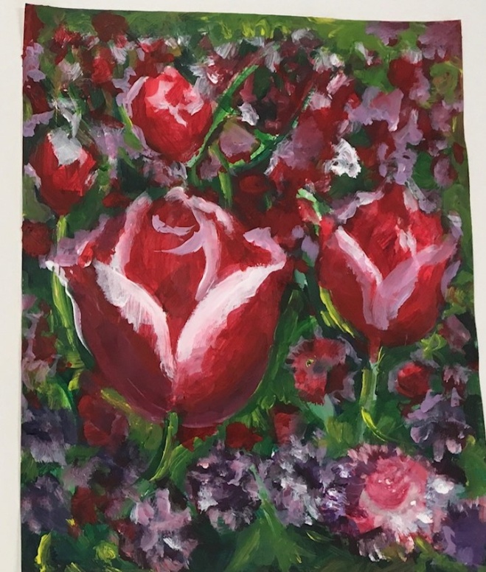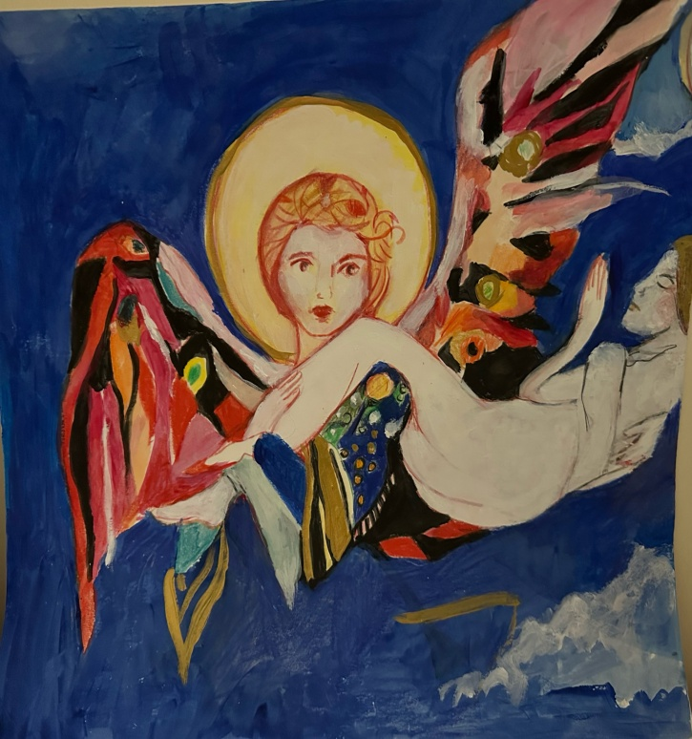
Summer tulips, Holland Angel’s Prayers
Park (work n progress)
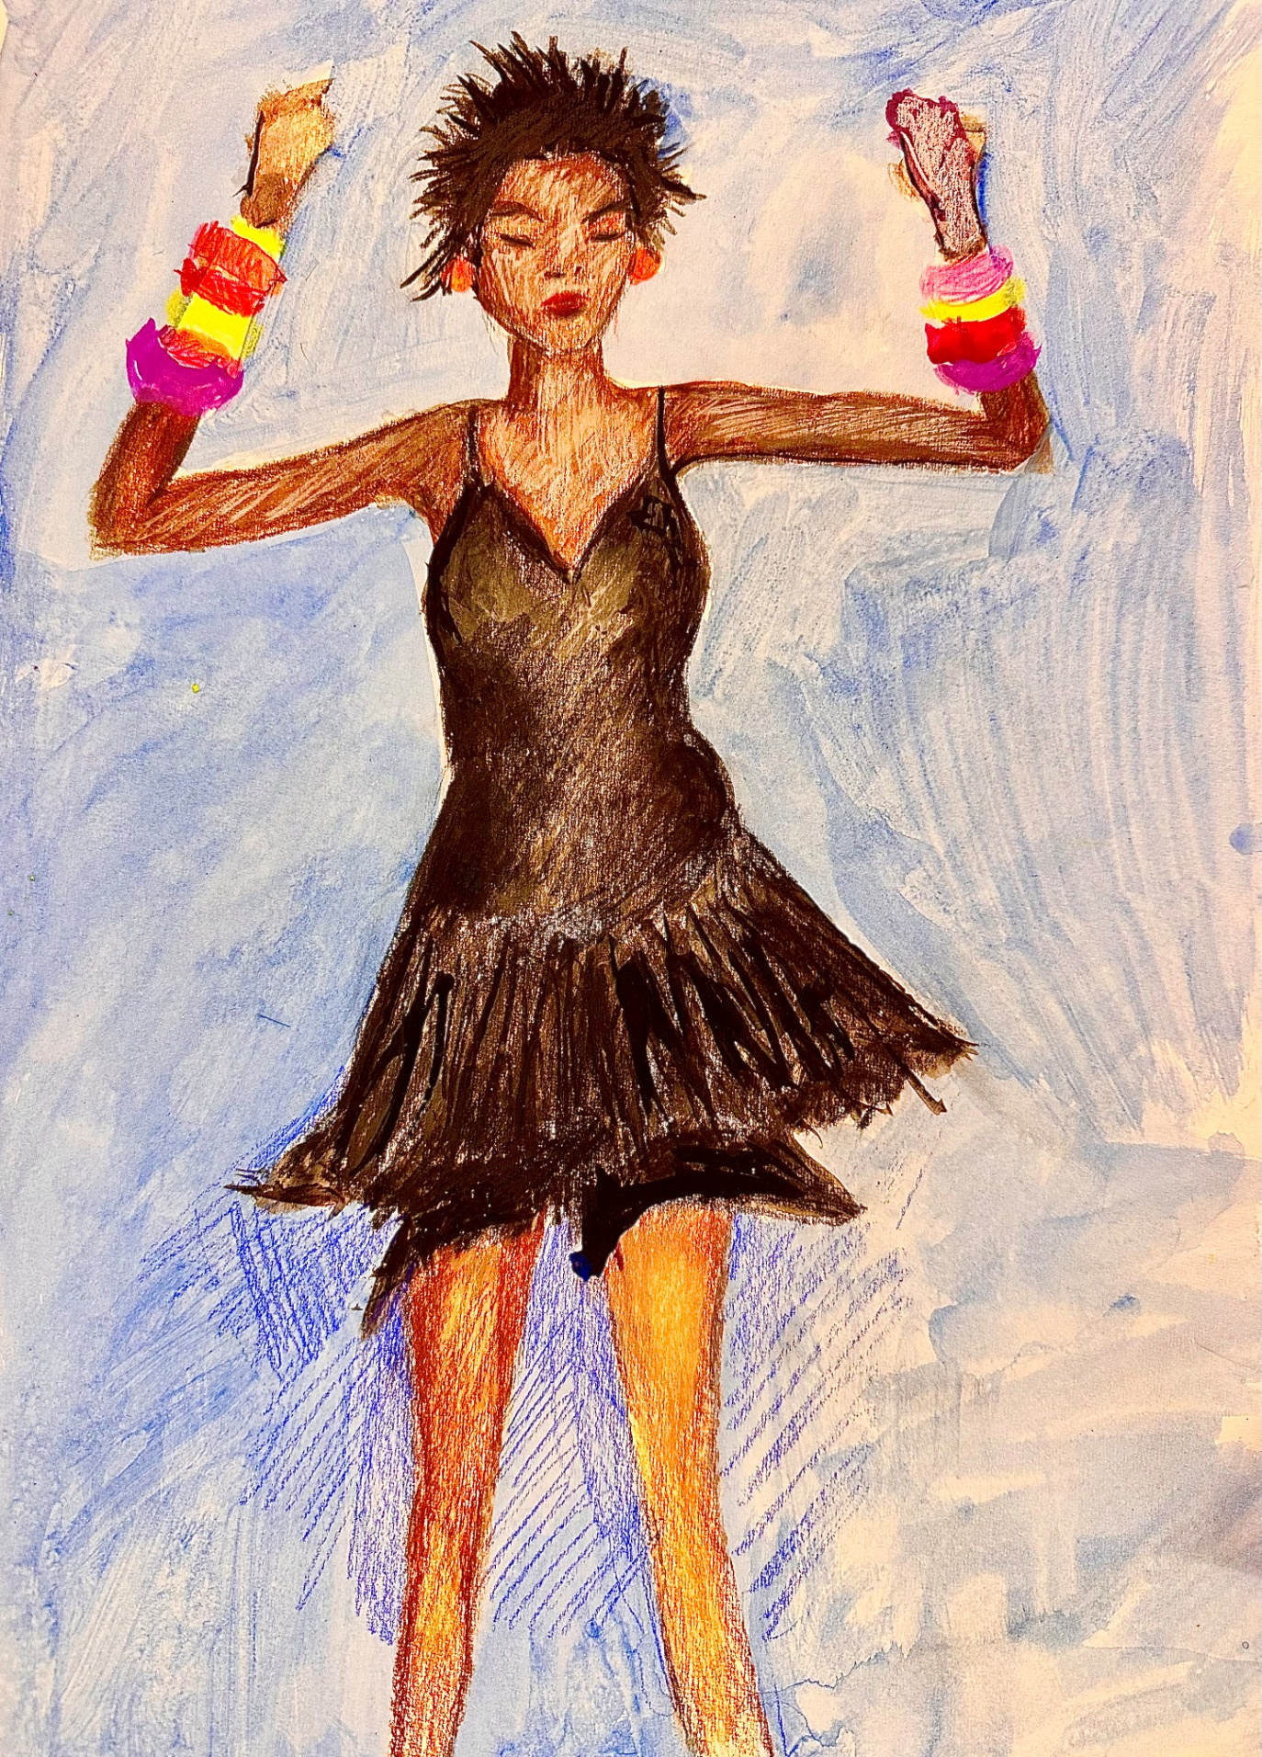
Dancing Lady
ADKC’s USER-LED GROUPS – MEETINGS:
(At The ADKC Centre and online)

Access Group
A group of local disabled people who campaign to make Kensington and Chelsea a more accessible place.
Twice a month on a Thursday, 3 PM - 4.30 PM.
Contact Mariya at Access@adkc.org.uk for more information.

Happy Group
A fun meeting to help people recognise the positives in life!
Every 1st Monday of the month, 11 AM - 1 PM.
Contact Glenda at PersonalDevelopment@adkc.org.uk for more information.

Personal Budget User Group
Peer support sessions about care issues for anyone who receives care and support, whether paid for by a council Personal Budget, through CHC Personal Health Budgets, paid for privately, or support from a friend or relative.
Every 3rd Wednesday of the month - from 11 - 1 PM.
Contact Jenny at IndependentLiving@adkc.org.uk for more information.

Personal Development Group
A monthly workshop providing members with one-to-one support to develop their skills and interests. 1st Wednesday of each month, 11 AM - 1 PM.
Contact Glenda at PersonalDevelopment@adkc.org.uk for more information.

Positive Empowerment Group (PEG)
Confidential peer support and counselling group. Friendly group atmosphere - any issues welcome.
Every 3rd Monday of the month, 11 - 1 PM.
Contact Glenda at PersonalDevelopment@adkc.org.uk for more information.
Positive Rights Action Group (PRAG) / Voice Of Experience Group
Campaigning group run by and for local disabled people.
Every 2nd and 4th Monday of the month, 12 PM - 1 PM.
Contact Theresa at VoiceOfExperience@adkc.org.uk for more information.
Trauma Support Group
An opportunity to talk in confidence and receive the support you need to deal with traumatic experiences (including isolation) with an experienced counsellor at hand.
Every Tuesday, 11 AM – 1 PM.
Contact Glenda at PersonalDevelopment@adkc.org.uk for more information.

